Creating Fractions in Word

Simplified solution
Simple just copy the fraction (from the list below) and copy and paste into your document, highlight the fraction component then type number to whatever fraction you wish to use.
i.e. copy the fraction ³/₇ then paste it into your text line
now change the components of the fraction.
i.e. copy the fraction ⁵/₂₄ then paste it into your text line
Problem solved….
Larger - highlight the fraction and change the font size if you want it larger
i.e. copy the fraction ⁵/₂₄ then paste it into your text line

¹/₃ ¹/₄ ¹/₅ ¹/₆ ¹/₇ ¹/₈ ¹/₉ ¹/₁₀
²/₃ ³/₄ ⁴/₅ ⁵/₆ ³/₇ ⁷/₈ ¹⁶/₉ ²¹/₁₀
⁸/₁₉ ¹/₂₁ ⁷/₁₁₁ ¹/₈ ¹/₇ ¹/₈ ¹/₉ ¹/₁₀

Or to do this correctly follow the rules below.

Microsoft 2004
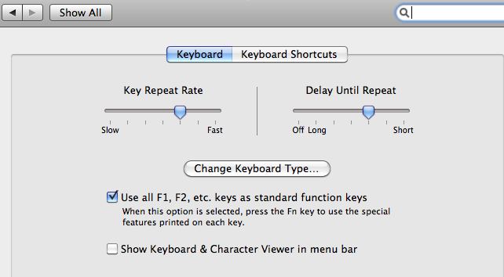

Use standard F keys
Usually typing a half 1 slash 2 will automatically convert to a fraction but what about other fractions 3/5, 4/7
½

Type (Windows) CTRL + F9 or (Mac) CMD +F9

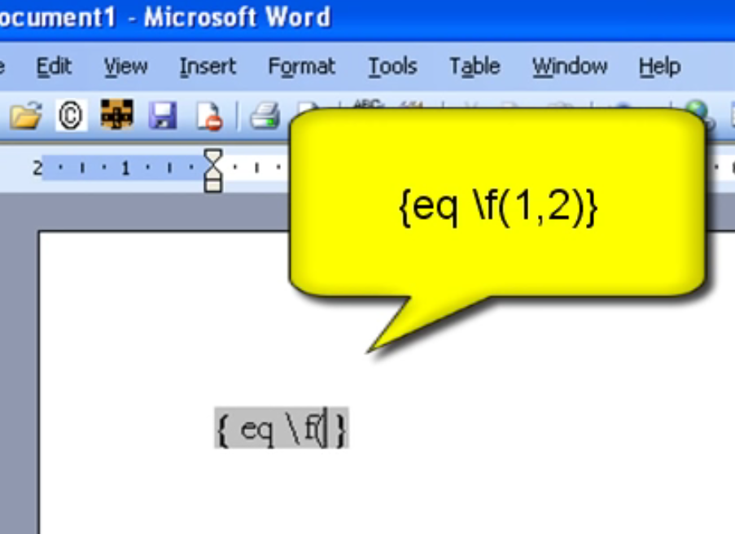
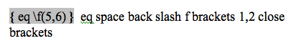
eq space back slash f brackets 1,2 close brackets
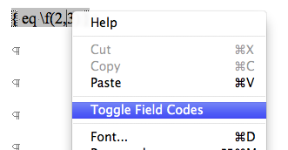

Right mouse click and select Toggle Field Codes

Reslut is a fraction
x $2\begin{aligned}\frac{5}{}\end{aligned}$
Double click on fraction to change but will be smaller
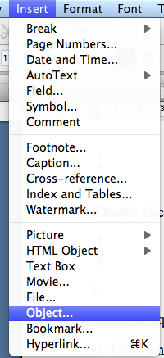
Insert an equation
1. Click where you want to insert the equation.
2. On the Insert menu, click Object.
3. In the Object type box, click Microsoft Equation.
4. Click OK.
5. Build the equation by selecting symbols from the Equation toolbar and typing variables and numbers.
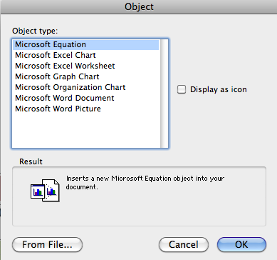
From the top row of the Equation toolbar, you can choose from more than 150 mathematical symbols.
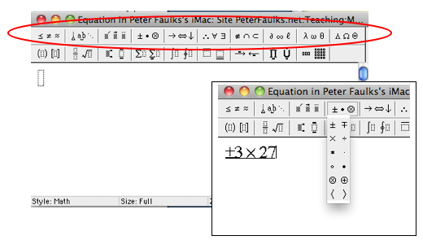
From the bottom row, you can choose from a variety of templates or frameworks that contain symbols such as fractions, integrals, and summations.
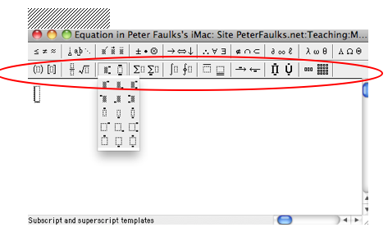
$±3´\text{27}$For Help on creating an equation, click Equation Editor Help on the Equation Editor Help menu. When you are finished creating your equation, click Quit Equation Editor on the Equation Editor menu.
Microsoft Office 2010 and 2013:
- Place the cursor on the document where you would like to insert a fraction.
- Select "Insert" from the menu.
- Click on Equation in the upper right.
- Select fraction under the Equation Tools option.
- Choose which style fraction you want.
- Insert the numbers into the fraction boxes.

Word 2016
Some fractions (1/4, 1/2, and 3/4) automatically switch to a fraction character when you type them (¼, ½, ¾). But others do not (1/3, 2/3, 1/5, etc.).
- To switch to a fraction character, click Insert > Symbols > More Symbols.
- In the Subset drop-down list, click Number Forms and select a fraction.
- Click Insert > Close.
Simple (see start of this document) just copy the fraction and copy and highlight the fraction component then type number (paste fraction to your document)
¹/₃ ¹/₄ ¹/₅ ¹/₆ ¹/₇ ¹/₈ ¹/₉ ¹/₁₀
²/₃ ³/₄ ⁴/₅ ⁵/₆ ³/₇ ⁷/₈ ¹⁶/₉ ²¹/₁₀
⁸/₁₉ ¹/₂₁ ⁷/₁₁₁ ¹/₈ ¹/₇ ¹/₈ ¹/₉ ¹/₁₀

